SITE PLAN WHITEWATER RAFTING

“RAFTING ADVENTURES”

1. 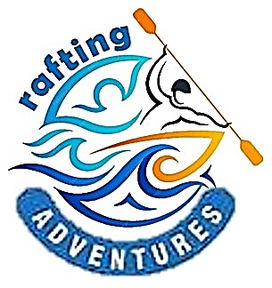The image selected for the site logo.
2. Write out the four (4) color labels (listed below) with the color codes you selected:

* primary-color #0b9e8d
* secondary-color #cb7429
* accent1-color #78e9c5
* 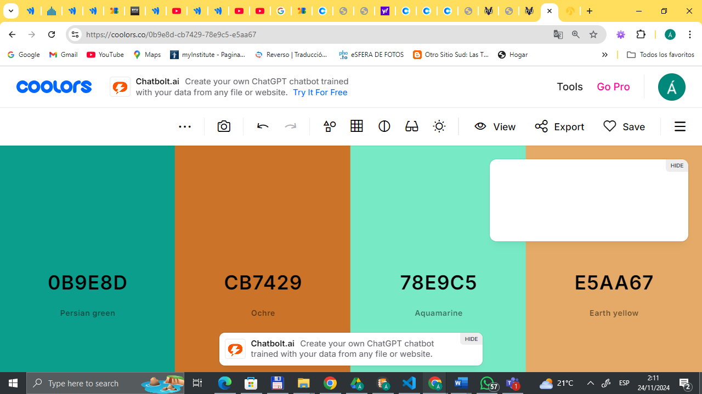accent2-color #e5aa67

1. The names of the fonts you selected:

heading-font  Quicksand 300 and 500

text-font  Roboto 100 and 400

1. 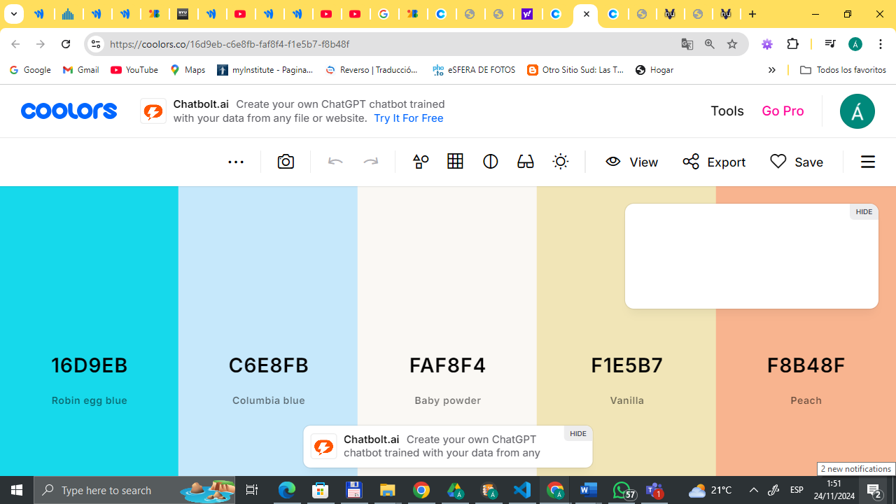The URL link to the color palette designed in coolors.co  
   <https://coolors.co/16d9eb-c6e8fb-faf8f4-f1e5b7-f8b48f>